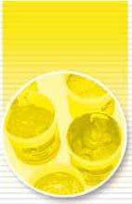

ADESIVO W
Code: AM150007

PRODUCT DESCRIPTION
Water based concentrated adhesive for pallets.

APPLICATION FIELDS
Water based adhesive indicated for:
tables, carpets and pallets for textile screen printing.
GENERAL & TECHNICAL FEATURES

- Indicated for heavy fabrics
- Easy to apply
- High adhesion
- Eco friendly
- Solvent free
- No smell

PREPARATION
Ready to use. It can be diluted with water in the maximum percentage of 30%.

APPLICATION
Apply the mixture through a brush, a squeegee, a paint roll or by spraying it. Once the product has been applied let it dry at room temperature. Wash the used tools with water immediately after use. The adhesive may be removed with water.

CLEANING
Wash tools with water.

SHELF LIFE
If stored in its original container at a temperature between 15 and 25°C ADESIVO W will preserve its features for about 1 year from the date of production.

SPECIAL INSTRUCTIONS
Before to use the product, we suggest to make some tests in order to evaluate if the it satisfies the requirement.

