Drying Rack assembly

Screen Print World

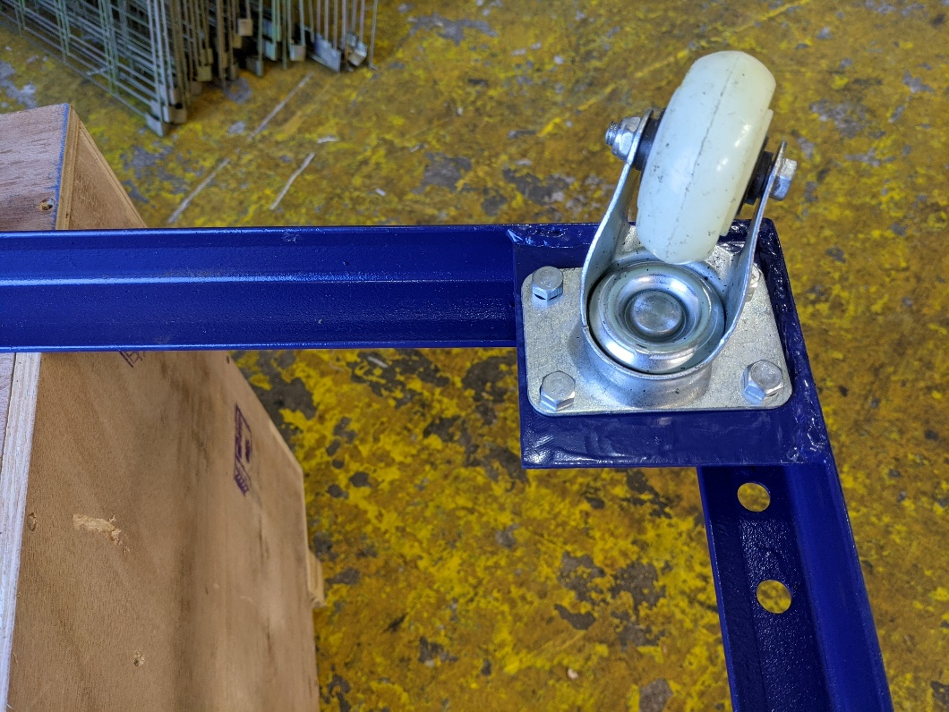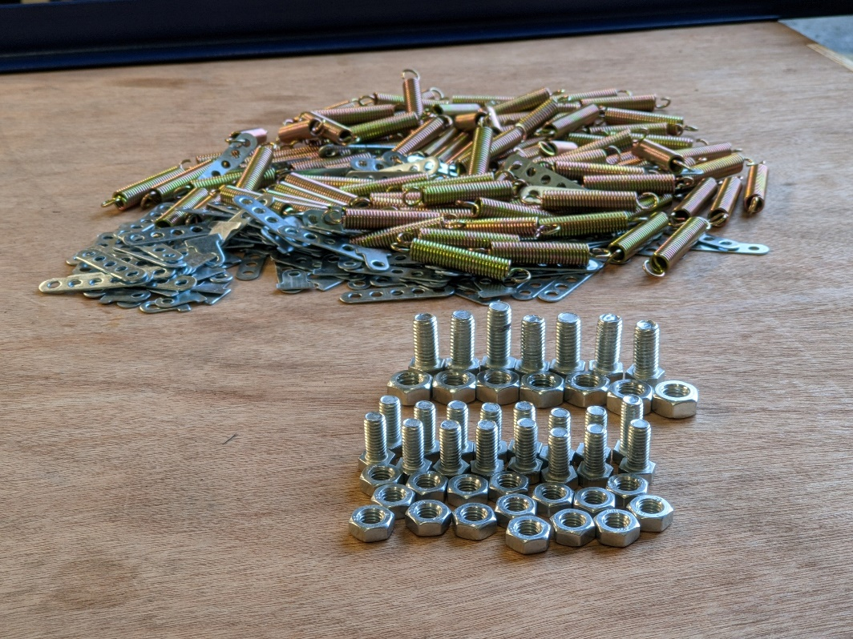

Step 2.

Take four of the smaller bolts and nuts and attach the wheels to the bottom frame of the rack. Once all four bolts and nuts are in position, you can use two spanners to tighten them fully. Repeat this step four times until all wheels are in place.

Step 1.

Take the contents of the bag out and arranged all the pieces so they are ready to hand.

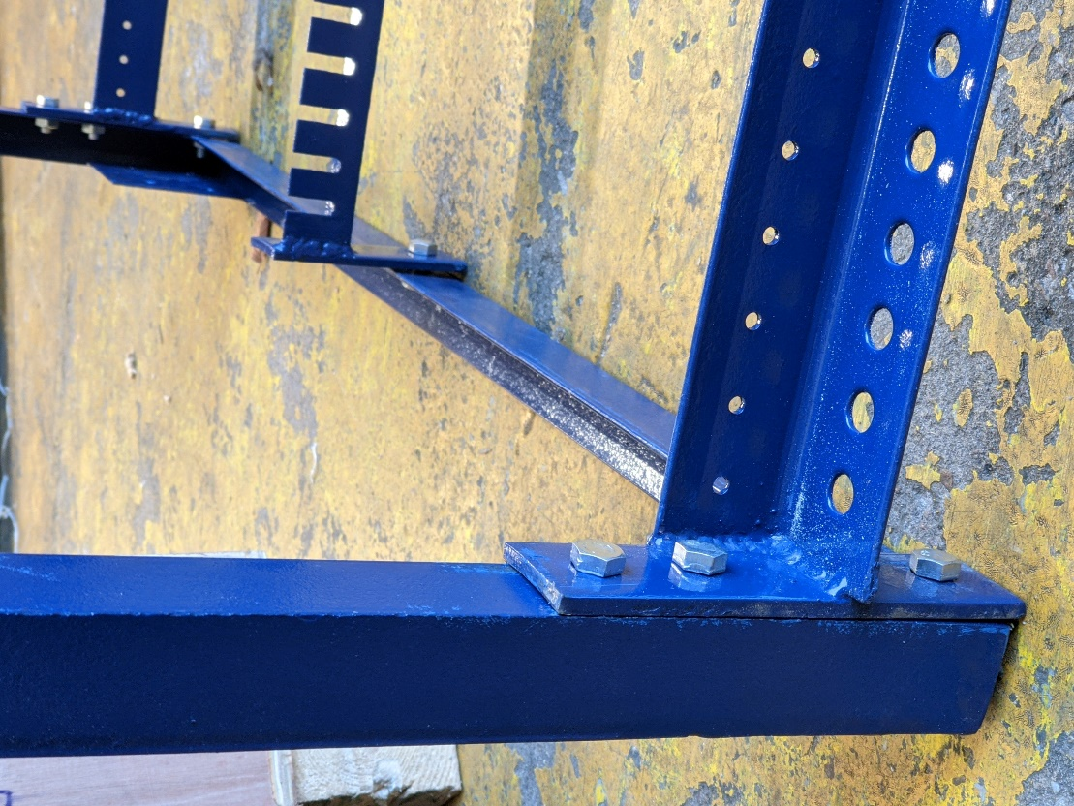

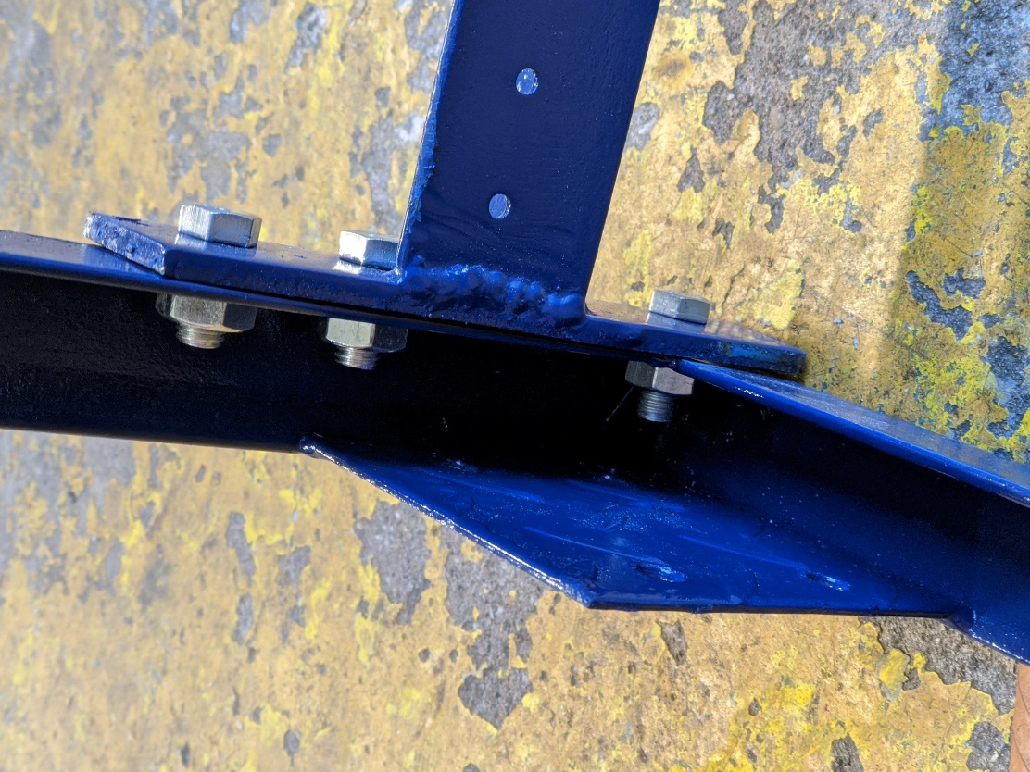

Step 3.

Take the tall back piece of the rack and lay it down on it’s back. Then, offer up the bottom frame (that you just attached four wheels to) against it so that all three holes on either side are aligned. Then fasten these two pieces together using three of the larger bolts and nuts on the left and right sides of the rack and one in the middle.

Do not fully tighten the bolts until all bolts are in position, or it will make it difficult to align the holes. If you are struggling to align the holes the frame can be gently bent into position the holes align, then push a bolt through to hold it in position. Once complete, use two spanners to tighten fully.

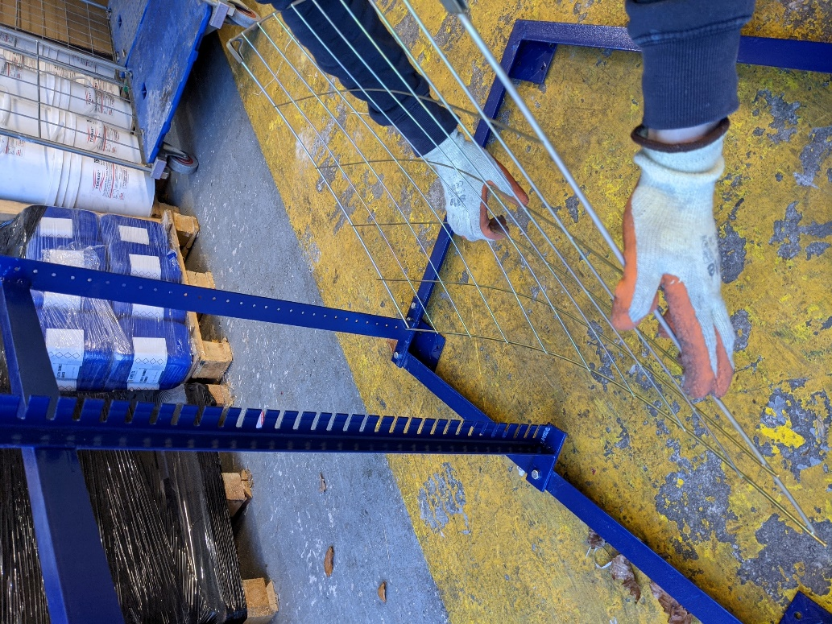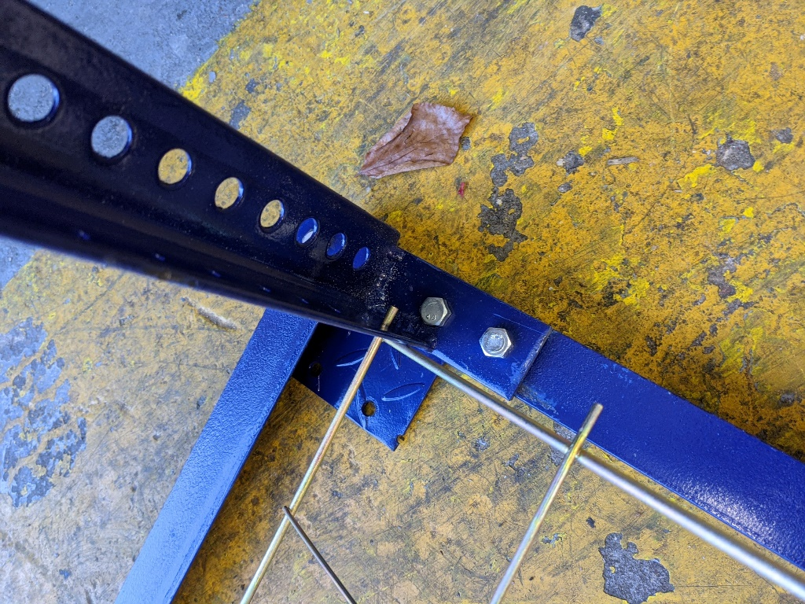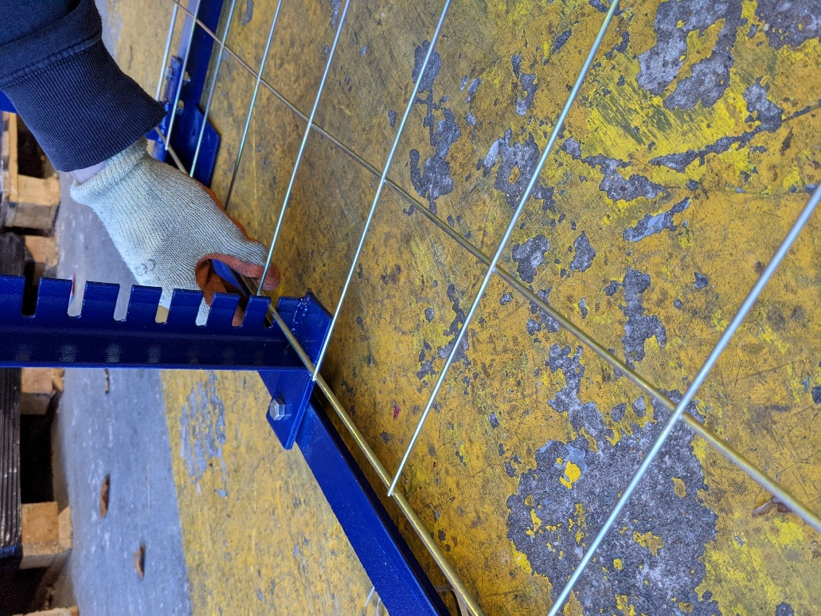

Fig c.

Fig b.

Fig a.

Step 4.

Attach the shelves

To do this, take a shelf and slot it into the hole on the right-hand side (Fig a). Then, with your left hand on the left side of the shelf, offer up the shelf to the hole on the left side of the rack and at the same time use your right hand in the middle of the shelf to flex it backwards, thus allowing the left side to pop into place (Fig b). Then push the shelf up so that it fits into the back of the rack (Fig c).

Start from the bottom and work your way up until all the shelves are in place.

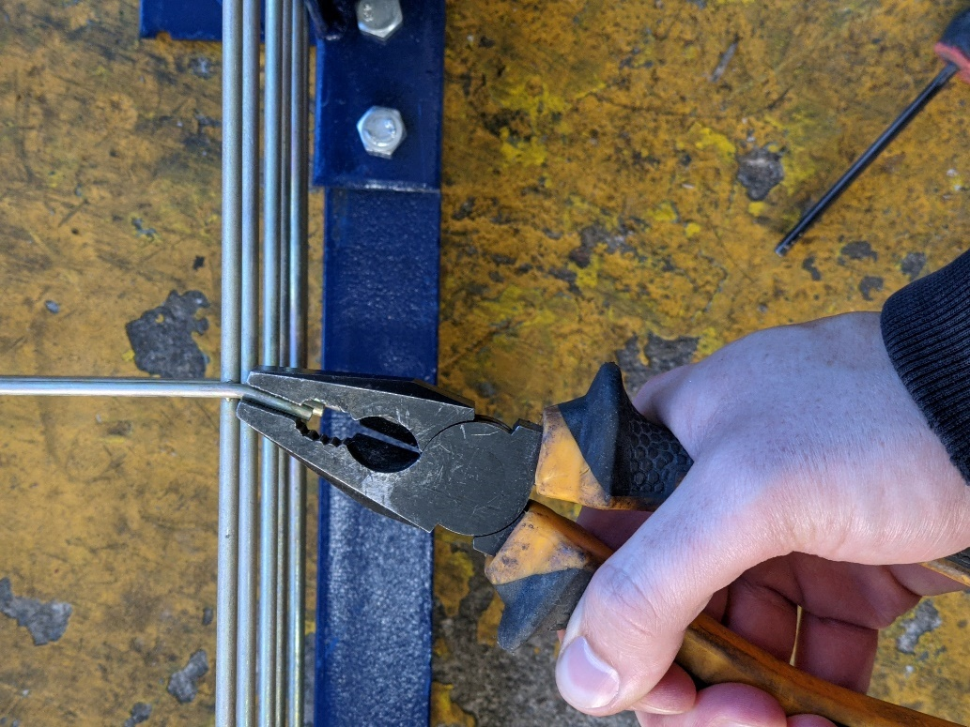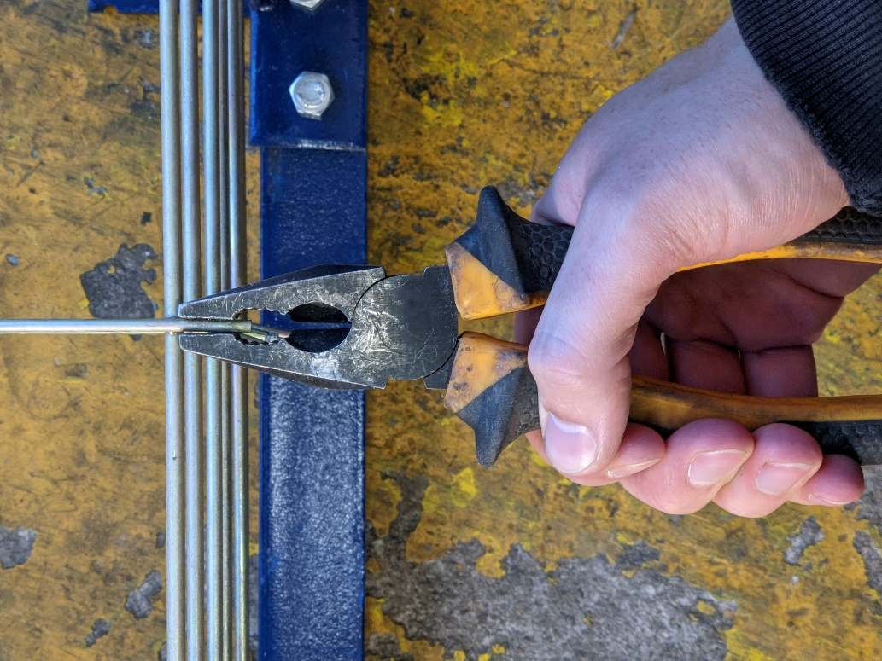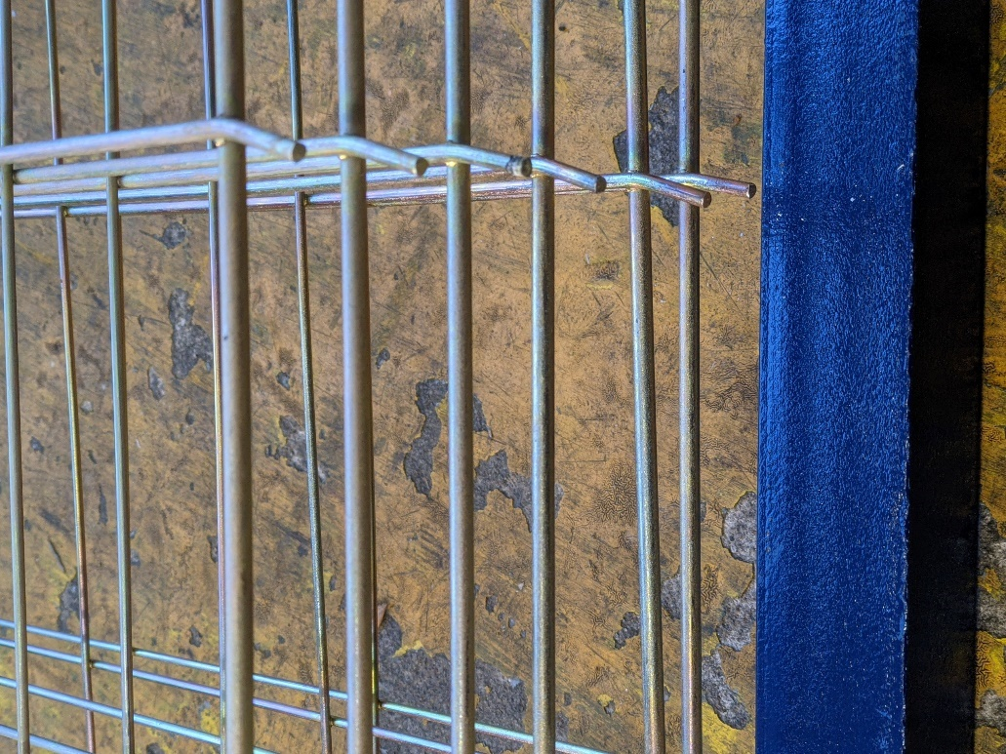

Step 5.

Take a pair of pliers and bend the pin that the spring attaches to forward.

Repeat this for every shelf on both sides until complete.

You must do this to ensure that the spring does not slip off.

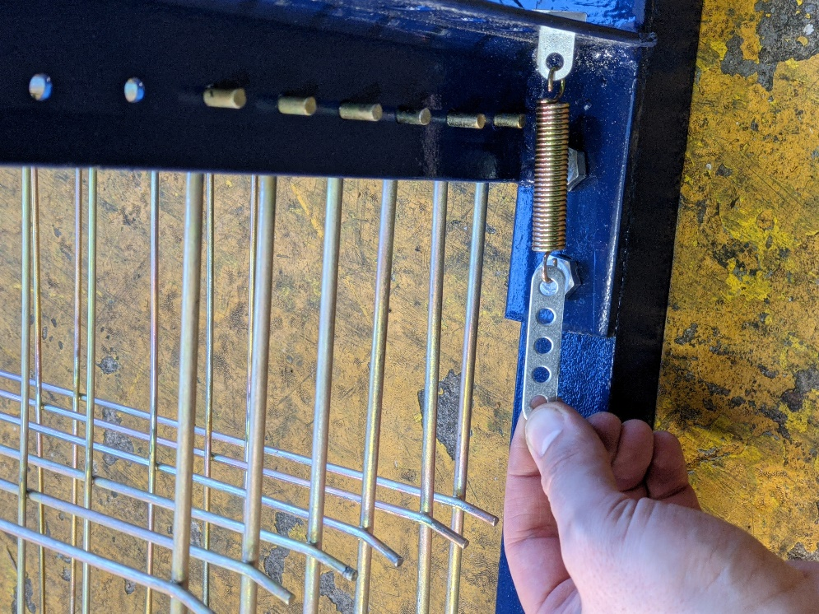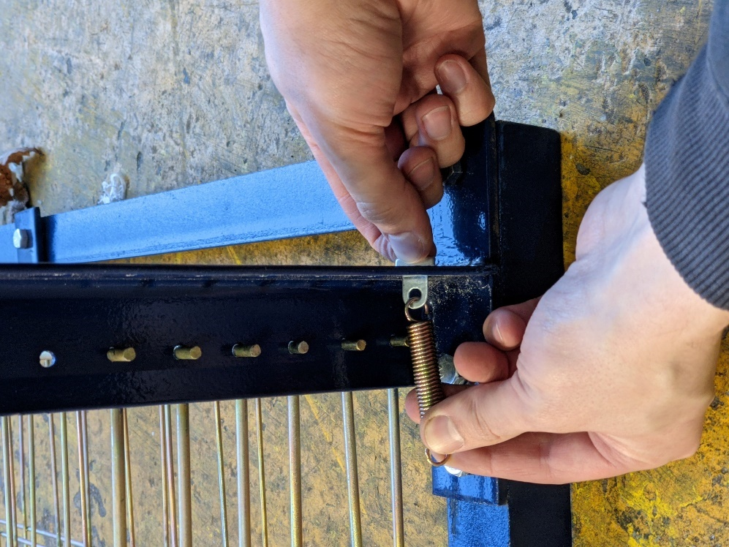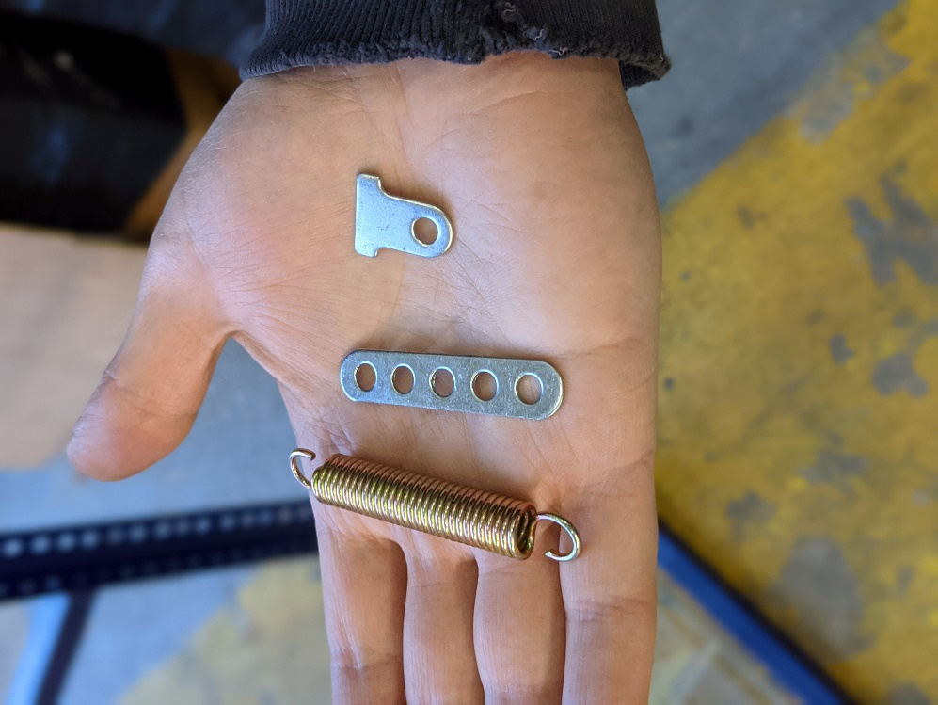

Step 6.

Attach the springs.

To do this, take the three pieces in the picture above. Start by pushing the small piece with one hole through the back of the rack and at the same time hook the spring through the hole.

Then take the long piece with five holes and hook the spring through the last hole.

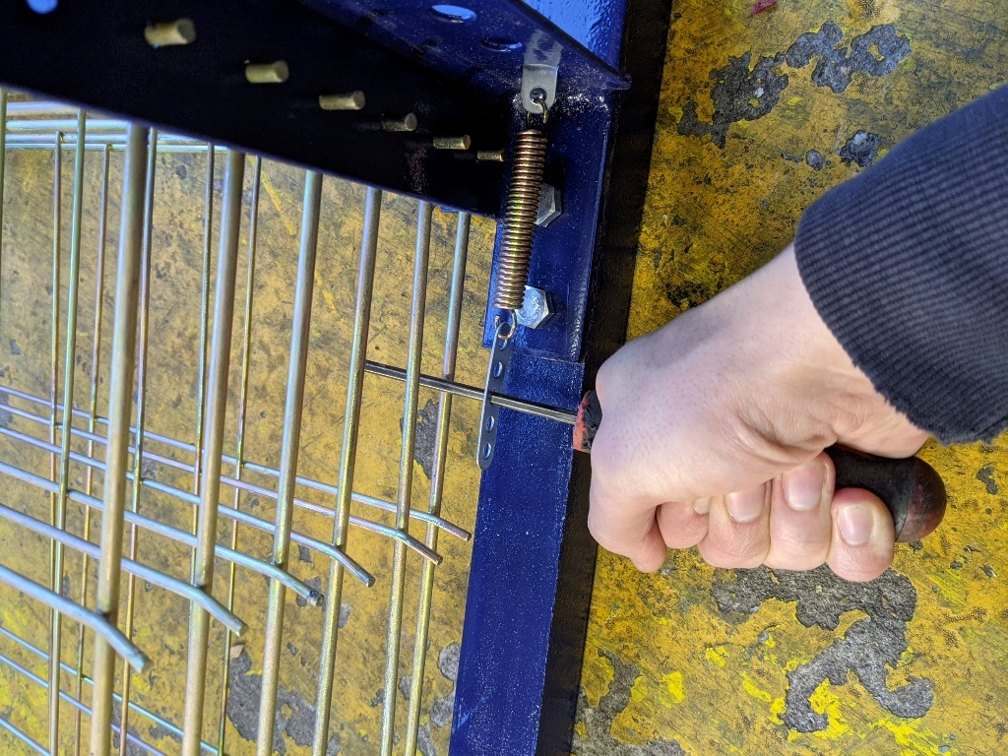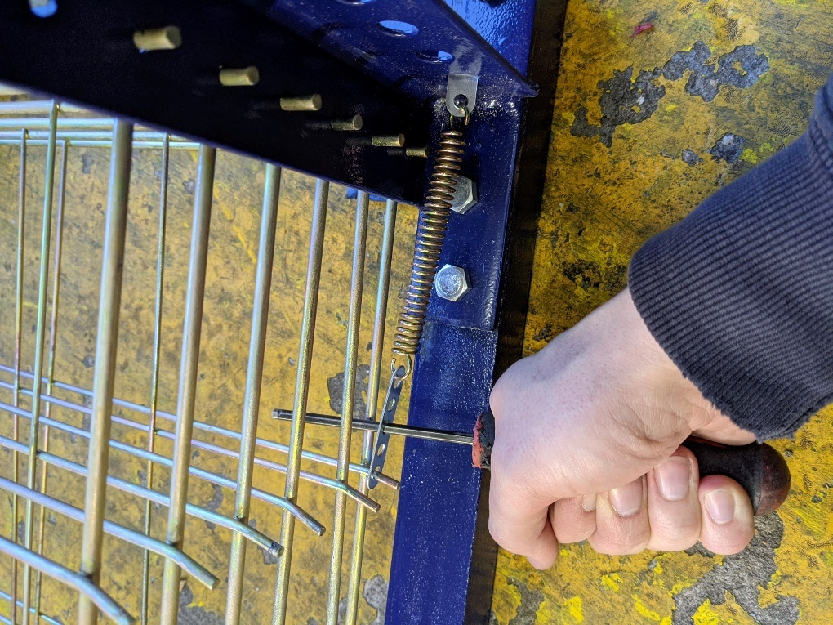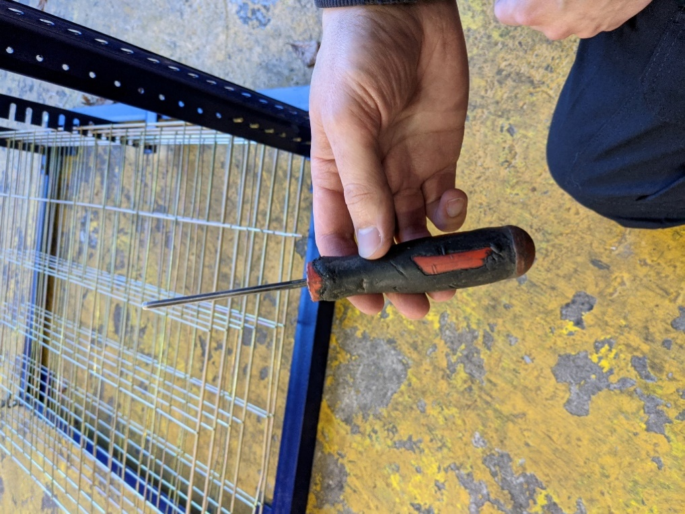

Step 7.

Attach the springs.

Using a screwdriver or tool like that in the picture, insert the tool through the middle hole in the metal piece and using your other hand to steady the rack, push the spring forward until the first hole reaches the pin.

Please ensure that you wear safety goggles whilst completing this step.

Repeat this step until every shelf is complete.

The rack is now complete.