PRINTYLON
Code: AM1104

PRODUCT DESCRIPTION
Solvent based ink with semi-glossy finishing.

APPLICATION FIELD
PRINTYLON is indicated for printing on nylon fabrics, Tyvek bags, fake-leather and water- proofed fabrics.
The product is also indicated for the realization of sliding and dry decals.
GENERAL CHARACTERISTICS
•

•
•
F&T (Food and Toys), lead and heavy
metals free, comply to EN71/III High opacity and printability
Good
outdoor
and
sea
water
resistance
- Quick drying

PREPARATION
Before using it, the ink must be mixed well and in case diluted according printing requirements.
It is possible to improve the hardness of the printed film adding the 10%/20% of PRINTYLON INDURITORE CONCENTRATO.
POTLIFE OF PRINTYLON BIANCO HR with 15% INDURITORE 2-3 hours.
POTLIFE of other colours with INDURITORE 6-8 hours.

PRINTING
To obtain best results use screens from 77 up to 120 threads/cm both for manual printing and automatic.

POLIMERIZATION & TECHICAL FEATURES
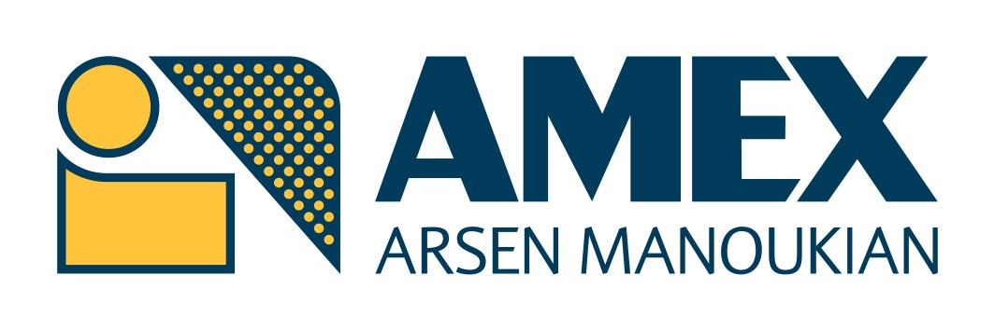By solvent evaporation at room temperature (15-20 min), it can be accelerated with the use of forced air
oven, according to the hot resistance of
* These data are highly influenced by the kind of
substrates printed, by the altitude and air pollution.
Tel. + 39 031 931923
Website: www.amexsrl.com
Amex srl gives the a/m suggestions as guidelines for the customer and assumes no liability direct or indirect for any improper use. It is the user's
responsibility to determine the suitability of the product to the intended use according to working conditions.
the material. In this case polymerization takes 20 seconds at 40-50°C.
PRINTYLON series has an outdoor resistance up to 1 year*.

THINNER
DILUENTE 201 R fast thinner DILUENTE 202 M medium thinner DILUENTE 203 L slow thinner
RITARDANTE 204 to slow drying on the screen.

CLEANING
Wash tools and screens after printing with SOLVENTE 108.

PACKING
1 -5 KG.

RANGE
12 colours ready to use. WHITES:
PRINTYLON WHITE excellent printability, elasticity and good opacity.
PRINTYLON WHITE SUPER: excellent printability, elasticity and excellent opacity PRINTYLON WHITE HR: excellent printability, elasticity and good opacity. High chemical and mechanical resistance.

NOTE
Before to use the ink in production, we suggest to make some tests in order to evaluate if the product meets customer’s needs.

