EXPOSURE CALCULATOR

PRODUCT DESCRIPTION

AMEX Exposure Calculator is a film with 5 columns.
Each column has a resolution target, a set of half-tone tints and lines of text. Each column is marked with a factor number and four columns are backed with a UV grey neutral filter of different density.

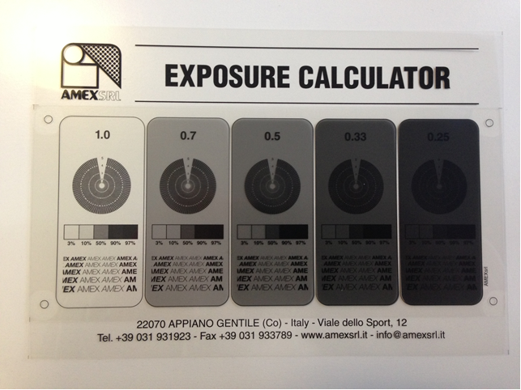

This format enables five different exposures to be made simultaneously.

WORKING INSTRUCTIONS

1. Estimate the correct exposure time, using the guidelines supplied with AMEX photoemulsion TDS, then double it.
For example an exposure time of 60 seconds should be doubled up to 120 seconds.

2. Expose the photostencil to the calculator in the normal way, washout and dry thoroughly.

3. Examine the stencil to determine the correct exposure time. Interpretation of correct exposure depends on the design and the way of application (coating speed, photoemulsion thickness etc.).

READING THE RESULTS OF THE EXPOSURE TESTS EMULSIONS

The correct exposure for pure photopolymer, diazo and dual cure emulsions is the point at which the entire thickness of exposed stencil is fully hardened by the UV light. This process of exposing / hardening is accompanied by a colour change in the stencil.

Examining the Stencil:
1. The Stencil will show variations in colour from one column to the next. Follow the colour change from the lightest to the darkest until it stops. The factor where the colour change stops is the column that represents the right exposure.
2. Once the correct column has been chosen, multiply the factor on the top (1.0 / 0.7 / 0.5 / 0.33 / 0.25) by the exposure time. This gives the correct final exposure time for that stencil, mesh and light source combination.
3. Underexposure: if there is still a colour change on the factor 0.7 and factor 1.0, this indicates a completely underexposed stencil. So double the original test exposure and repeat the test.

THE EXPOSURE CALCULATOR TO TEST THE PRINTING DEFINITION

AMEX Exposure Calculator can be used also to assess the print edge definition and the print resolution. The target is designed to allow the user to select the best angle to position the stencil. Resolution is checked by assessing the degree of “filling-in” at the centre of each target.

HALTONE TINTS

The different halftone areas can be used to evaluate the degree of highlight dot loss and flooding
of shadow areas respectively. The examination of the print will show at a glance whether there is “dot loss” or “dot gain” in the mid tones.

SHELF LIFE & STORAGE

Keep the AMEX Exposure Calculator in a cool dry place away from heat, ignition sources and other reactive chemicals. Shelf life is 5 years when stored at a temperature from 0°C to 30°C.

Keep AMEX Exposure Calculator away from any source of water or heat as this can damage the neutral density filters.

It is recommended to test the performance of the product before starting to use it in production.

